Day 1 Assignment: Overview of Hardware
Components

Task 1: Desktop PC Hardware Architecture Diagram
Instructions: Use the workspace below to sketch or map out a labeled internal layout diagram of a desktop PC. Ensure you clearly identify and show connections for the Motherboard, CPU, RAM, GPU, HDD, and SSD.
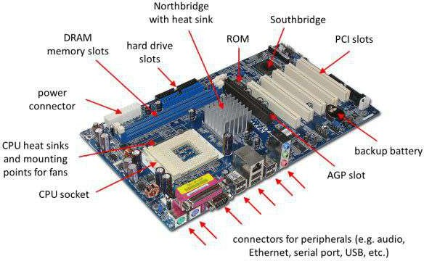

[ Interactive / Illustrative Diagram Space ]
Please draw your system blueprint here. Label the core components explicitly and map the data paths (e.g., SATA/NVMe lanes from storage
to motherboard, and PCIe connection for the GPU).

Metric /
Hard Disk Drive (HDD) Solid-State Drive (SSD)
Attribute
Data Transfer Speed | Slower read/write latency (typically  80-160 MB/s). Subject to physical seek time of the drive arm and platter RPM. | Significantly faster (500+ MB/s for SATA, up to 7000+ MB/s for PCIe NVMe) due to direct electronic flash cell mapping.
Mechanical Durability | Low shock resistance. Vulnerable to structural damage or data corruption if dropped or subjected to heavy vibration while active. | High physical durability. No moving parts make it entirely shock-resistant and ideal for rugged or portable operational deployment.
Primary Deployment & Use Cases | High-capacity bulk archiving, secondary data arrays, network-attached storage (NAS), and budget media servers. | System boot drives, operating systems, demanding gaming PCs, production software, laptops, and real-time processing systems.

Task 2: Storage Architecture Comparison (HDD vs. SSD)
Complete the technical evaluation matrix below comparing magnetic platter storage with solid-state flash memory structures.

Task 3: Computational Component Analysis in Active Gaming Realities
Describe the discrete runtime functional responsibilities of the CPU, RAM, and GPU when executing modern graphics-heavy games (such as PUBG or Free Fire).

Central Processing Unit (CPU) Role:
The CPU operates as the primary logic and coordination brain during gameplay. It handles real-time game physics engine calculations, processes complex artificial intelligence (AI) logic for enemy bots, processes networking packets for multiplayer sync, and computes user input registration. Without an adequate CPU, frame rendering will stall as the engine fails to track game states.

Random Access Memory (RAM) Role:
RAM functions as a high-speed volatile data buffer holding active environment state variables and immediately accessible game assets. It temporarily stores the active map geometry, player positioning grids, audio files, and systemic game scripts pulled from long-term storage. This enables immediate CPU execution without encountering severe storage latency or stutters during fast-paced motion.

Graphics Processing Unit (GPU) Role:
The GPU processes massive parallel graphics math to render visual elements on screen. It is responsible for calculating complex vertex layouts, mapping texture pixels onto 3D models, calculating dynamic lighting/shadow maps, and outputting finished frames continuously to your monitor. A powerful GPU directly determines high frame rates (FPS) and resolution quality.

Task 4: Component Strategic Upgrade Planning Scenario
Contextual Scenario: Planning an architectural component upgrade path to safely run the latest iteration of demanding video games (e.g., FIFA) smoothly at native framerates without visual bottlenecks.

Component 1: Graphics Processing Unit (GPU)
Reasoning: Upgrading the GPU yields the most significant performance bump for visual fluidity in titles like FIFA. Modern sports engines rely extensively on intense multi-source shadow computations, physical cloth rendering for jerseys, and realistic skin shaders. Moving to a modern GPU ensures that the frame time stays well below 16.6ms for an uninhibited 60+ FPS experience at higher graphical presents.

Component 2: Solid-State Storage (SSD Upgrade via NVMe protocol)
Reasoning: Upgrading from an older mechanical HDD to a rapid NVMe M.2 SSD drastically improves loading times between stadium instances, cutscenes, and initial boot cycles. Furthermore, modern games stream higher-fidelity assets on-the-fly during active play; utilizing an SSD avoids asset pop-in glitches and mid-match micro-stuttering caused by slow storage response loops.

Component 3: Random Access Memory (RAM) Allocation
Reasoning: Moving from a standard 8GB single-channel configuration to a 16GB dual-channel configuration guarantees that background operating system processes do not force the system into virtual memory pagefile swapping. This ensures a healthy overhead headroom for high-fidelity asset caching, preventing unexpected framedrops when the engine handles massive dynamic stadium crowds.

